**Name : Hemalatha Karumuri**

**Date : 12/12/23**

**Python Programming**

* Python is an interpreted, object-oriented, high-level programming language invented by Guido Van Rossumin the late 1980s.

Python became popular and widely used language because of the following features :

#### 1.Simple

Compared to many other programming languages, coding in Python is like writing simple English sentences.

2.Easy to learn for the beginners because of its simple syntax.

3.Free and Open Source

Python and the majority of supporting libraries available are open source and we can access its source code, make changes to it, and use it in new free programs.

4.High-level Programming language

#### 5.Dynamically Typed: Types of variables, objects, etc. are generally assigned during runtime

#### 6.Portable: Being open source and also with support across multiple platforms

#### 7.Automatic Garbage collection

#### 8.Extensible language

#### 9.Multiparadigm :

Python supports various programming and implementation paradigms, such as Object Oriented, Functional, or Proceduralpro- gramming.

**Running a Python Program**

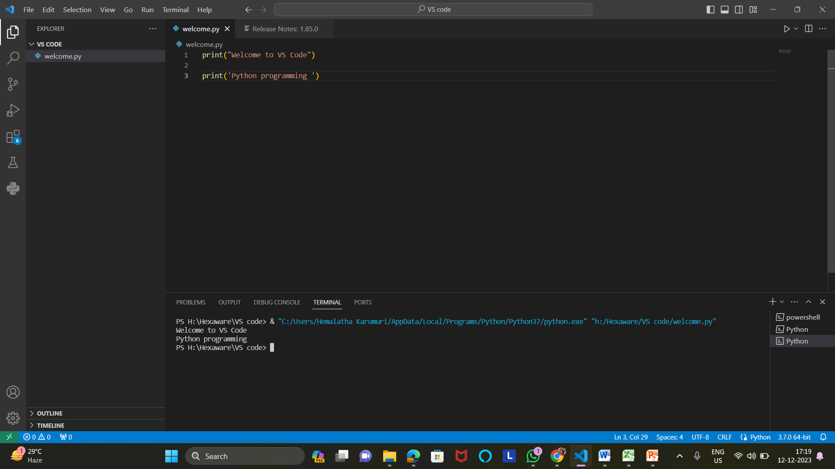

## Data Types

* Integer : EX : x= 30
* Float Ex: x=30.3
* String Ex: x=’str’
* Boolean Ex : x=true

**Variable :**

*used to store the data

*The declaration happens automatically when you assign a value to a variable.

*we can change type, simply by assigning them a new value of a different type.

**Taking the input on runtime and printing it**

